Team 1 Open Source Air Quality Monitoring

Week 15: April 17th 2022 - April 24th 2022

Sponsor: Dr. [David Burnett](mailto:dburnett@pdx.edu)

Advisor: Dr. John Acken

Team Members: [Adam Dezay](mailto:adezay@pdx.edu), [Manuel Garcia](mailto:manga2@pdx.edu), [Brandon Hippe](mailto:bhippe@pdx.edu), Mercedes Newton

**Team Review:**

* Team members are each working on specified sensor/component tasks.
* Team submitted new equipment request
  + New MSP430 boards
* Team received new equipment
  + PM sensor cables
  + Still waiting on anemometer
* Established communication with PM and eCO2 sensors! Data is coming in!
  + PM and eCO2 sensor code is complete and (hopefully entirely) debugged
* Breadboard prototype (minus anemometer and SmartMesh) is ready (shown in figure 2)
* Gantt chart and schedule for current term (shown in figure 1).
* Team decided to meet in person each week on campus at 2pm on Thursdays before advisor meetings
* Team will meet with Dr. Burnett for this week while Dr. Acken is at conferences.

**Individual Review**

Adam Dezay:

I finally got a signal to the sensors thanks to help from Brandon and Mercedes. We are getting CRC code error but were unable to quickly debug it. Needs more work.

Wiki caught up to week 14 of work. Gave my MSP430 to Brandon since his got fried

Manuel Garcia:

Got UART working on the MSP430. Successfully pulling outside data on the msp430, transmitting that data over UART to an esp32, hosting that data on a local server via the esp32 that is accessible via the web browser. Have not had successful transmissions with the smartmesh yet, but now that we can tell that we are successfully transmitting data we just need to figure out proper smartmesh pin settings and baud rate.

Brandon Hippe:

Fried an MSP430 (lesson learned: don’t short 5V and ground together if you don’t want a glowing inductor/resistor and magic smoke). Wired up breadboard prototype (shown in figure two) and worked on debugging PM and eCO2 sensor code. Both are working fully as intended. Wrote a library for anemometer so debugging can begin as soon as it arrives.

Mercedes Newton:

PM2.5 sensor updates - Continued debugging efforts for PM sensor and worked to connect to UART with brandon.

**Gantt Chart and Timeline Updates:**

Below is both the timeline of the projected project progress for spring term. Figure 1 represents the gantt chart for the term with expected completion dates beginning March 25th. All specific dates for the upcoming term are specified in the table below.

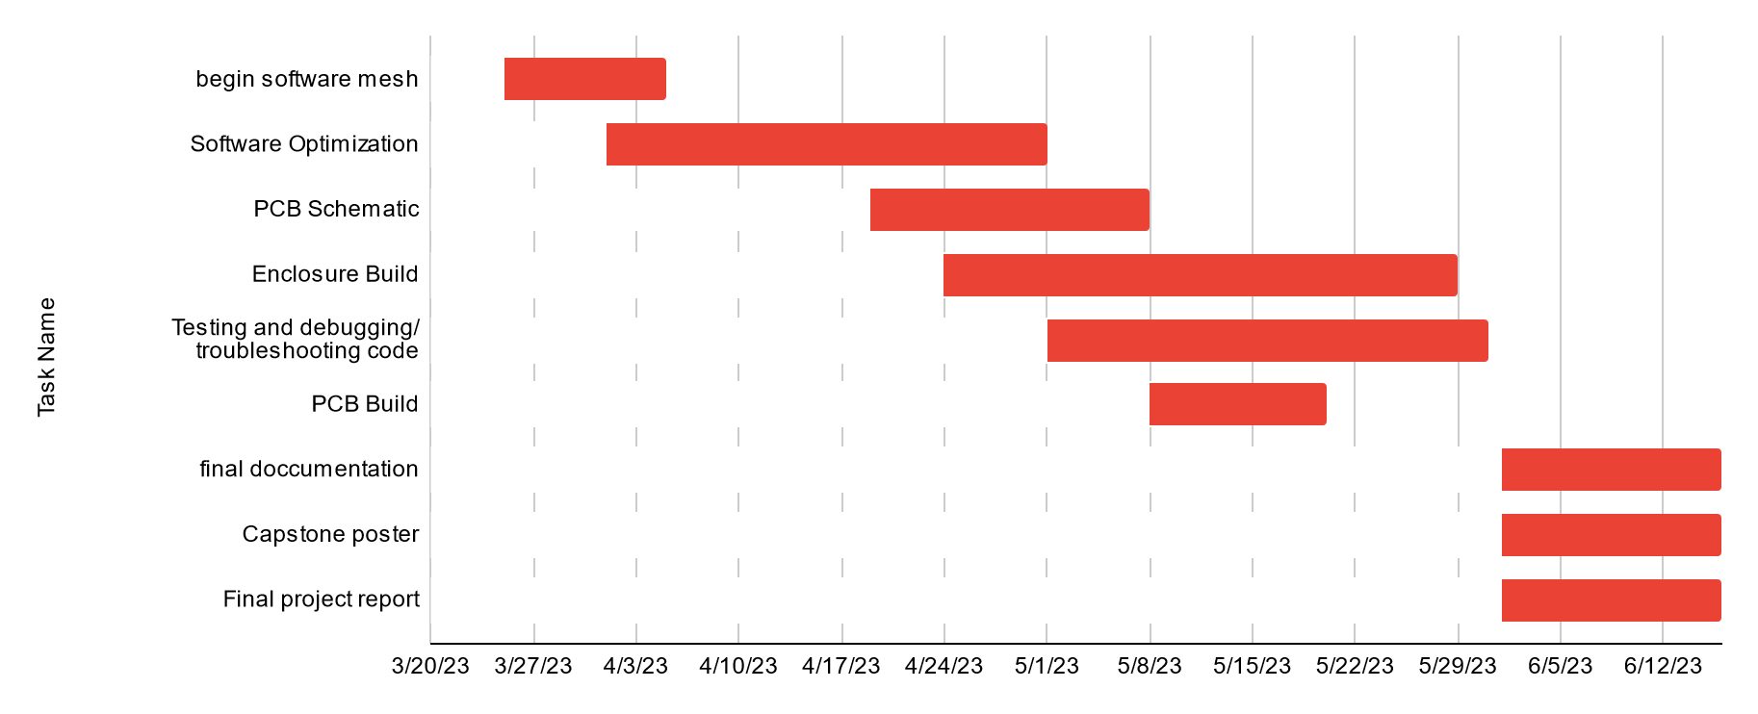

Figure One: Gantt chart for spring term (first task starts 3/25/2013)

| Task Name | Start date | End date |
| --- | --- | --- |
| Begin software mesh | 3/25/2023 | 4/5/2023 |
| Software Optimization | 4/1/2023 | 5/1/2023 |
| PCB Schematic | 4/19/2023 | 5/8/2023 |
| Enclosure Build | 4/24/2023 | 5/29/2023 |
| Testing and debugging/ troubleshooting code | 5/1/2023 | 5/31/2023 |
| PCB Build | 5/8/2023 | 5/20/2023 |
| final documentation | 6/1/2023 | 6/16/2023 |
| Capstone poster | 6/1/2023 | 6/16/2023 |
| Final project report | 6/1/2023 | 6/16/2023 |

Table One: Tasks for spring term with expected completion dates *completion dates subject to change*

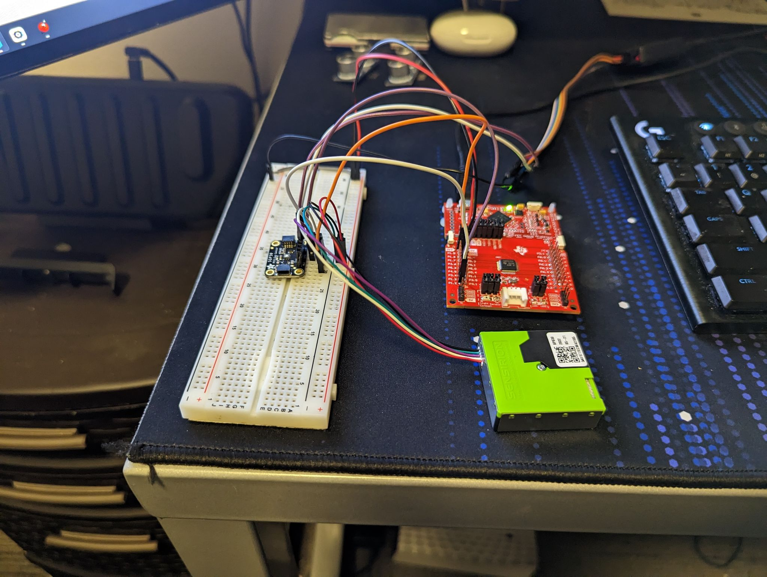

Figure Two: Image of Breadboard prototype

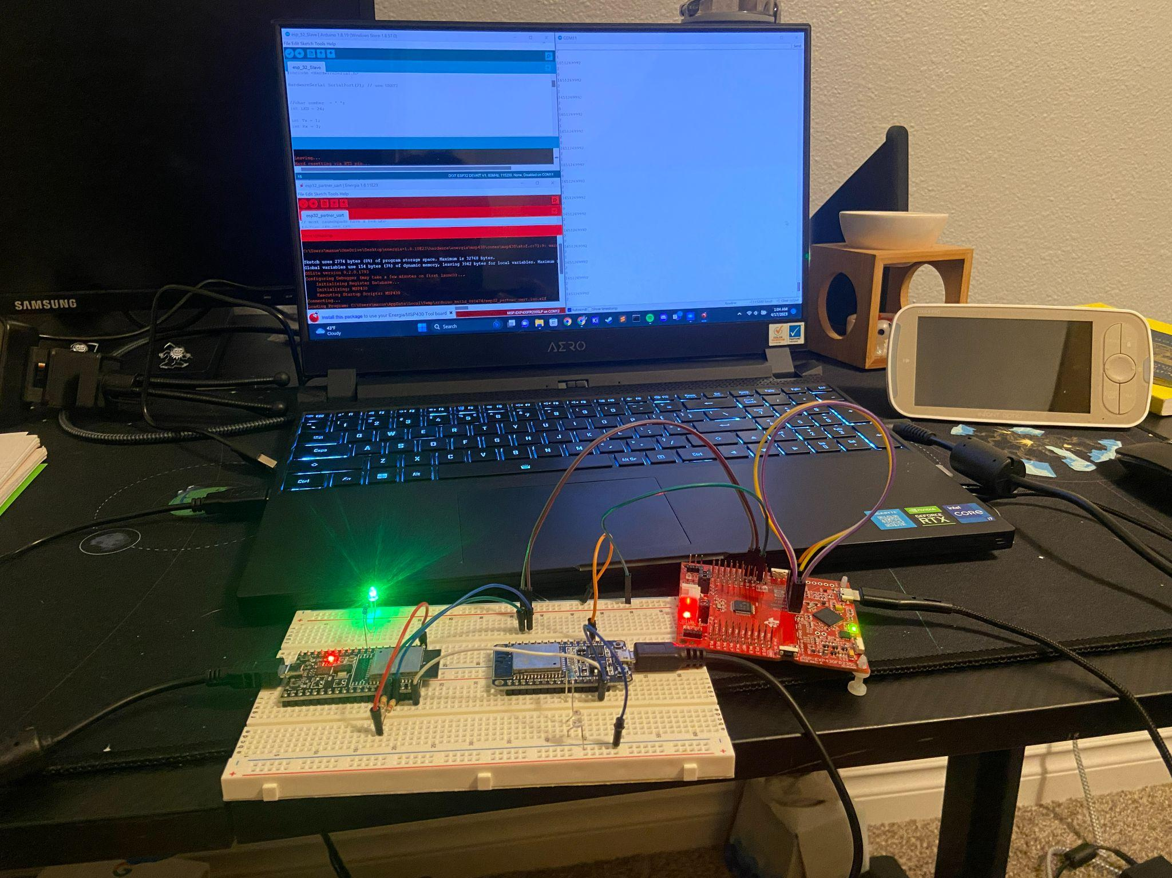

Figure Three: MSP430 transmitting to esp32 webserver